**McDonald's Menu Nutritional Analysis**

**Date: 24-10-2024 Prepared by: Prashant Makapur M**





**Introduction**

Dive deep into the world of McDonald's with a thorough analysis of their dataset, covering nutritional content and providing valuable insights through menu items, giving good ideas to McDonald's customers and much more. This analysis aims to provide valuable insights into the strategies that make McDonald's a global leader in the fast-food industry.

**Objectives of the report:**

* Extracting meaningful information from McDonald's menu nutritional dataset
* Performing exploratory data analysis to understand nutritional distribution and trends
* Creating visualizations to present calorie count and nutrition facts

**Extracting meaningful information from McDonald's menu nutritional dataset**

The **McDonald's Dataset** which contains **260 menu items**, organized into **9 distinct food categories**. This data captures the nutritional values of the items, focusing on five key nutrients: **Calories, Protein, Carbohydrates, Sodium, and Dietary Fiber**, and excludes certain nutrients and daily value percentages for a more streamlined analysis. The serving sizes in the dataset are huge but can be understood into two types: ***Weight-based servings* and *Volume-based servings***.

**Food categories:**

* **Breakfast: Breakfast items are rich in calories and protein but can also contain high**

**levels of sodium and total fat, which are key to analysing their overall health impact.**

* **Beef & Pork: Beef and pork menu items are high in protein, but they also have significant amounts of cholesterol and total fat, making these nutrients critical in evaluating their nutritional value.**
* **Chicken & Fish: These are excellent sources of protein while typically having lower fat levels than beef, but sodium and cholesterol content should be considered.**
* **Salads: Salads are typically lower in calories and rich in vitamins A and C, calcium, and dietary fibre, offering a lighter, nutrient-dense option on the menu.**
* **Snacks & Sides: These items often have high carbohydrate and sodium content, with some sides containing sugars that impact their nutritional assessment.**
* **Desserts: Desserts are generally high in sugars, calories, and fat, which are key nutrients to monitor when analysing their effects on overall diet.**
* **Beverages: Many beverages contain high levels of sugars and calories, with some also contributing to daily sodium intake.**
* **Coffee & Tea: While low in calories, coffee and tea drinks can vary greatly in sugar and fat content depending on the added ingredients like cream and syrups.**
* **Smoothies & Shakes: Smoothies and shakes are typically high in sugars, total fat, and calories, making them a key focus when assessing indulgent menu options.**

**Each food category is analyzed for its nutritional benefits and concerns, helping McDonald's provide healthier options and improve menu quality.**

**Key Nutrients in McDonald's Menu Items**

* **Calories: Measure of energy provided by the food.**
* **Calories from Fat: Portion of total calories that come from fat content.**
* **Total Fat: The total amount of fat in the item.**
* **Total Fat (% Daily Value): Percentage of daily recommended fat intake in one serving.**
* **Saturated Fat: Type of fat that can raise cholesterol levels.**
* **Saturated Fat (% Daily Value): Contribution to the daily recommended limit for saturated fats.**
* **Trans Fat: Unhealthy fat that can increase the risk of heart disease.**
* **Cholesterol: A substance linked to heart health, present in animal products.**
* **Cholesterol (% Daily Value): How much of the daily recommended cholesterol the item contains.**
* **Sodium: Salt content, which can affect blood pressure.**
* **Sodium (% Daily Value): The percentage of the recommended daily salt intake in one serving.**
* **Carbohydrates: Main source of energy from sugars, starches, and fibers.**
* **Carbohydrates (% Daily Value): Contribution to the daily recommended intake of carbs.**
* **Dietary Fiber: Aids digestion and promotes a feeling of fullness.**
* **Sugar: Simple carbohydrates that can affect blood sugar levels.**
* **Protein: Essential for muscle building and repair.**
* **Vitamin A (% Daily Value): Contribution to daily vitamin A intake, important for vision and immune function.**
* **Vitamin C (% Daily Value): Supports immune health and skin repair.**
* **Calcium (% Daily Value): Essential for bone strength and health.**
* **Iron (% Daily Value): Supports the transport of oxygen in the blood.**

**Understanding these key nutrients allows McDonald’s customers to make more informed decisions about their meals, helping them balance their diet and manage their health effectively. It helps organizations to enhance menu transparency but also support the development of healthier options preferences and promoting a more positive brand image focused on health and well-being.**

**Serving size:**

**Weight based serving:**

**These servings are measured in grams or ounces, providing a precise understanding of how much food is being consumed.**

* **Big Mac: 8.0 oz (227 g)**
* **French Fries: Medium size: 4.1 oz (116 g) Volume-based serving sizes:**

**These servings are measured in fluid ounces or millilitres, often used for liquids or foods that can be poured or scooped.**

* **Beverage(child): 12 fl oz cup**
* **Jug size: 1 carton (236 ml) Objective:**

**The primary objective of this analysis is to explore trends in the nutritional content of**

**McDonal’ds menu items. By examining key metrics such as Calories, Fat, Cholesterol, Carbohydrates, Protein, Iron, Vitamins, Sodium, Dietary Fiber and Sugar across various food categories, this report aims to uncover insights that can inform healthier meal choices, highlight nutritional imbalance, and provide an in-depth understanding of the menu’s overall nutritional profile. Additionally, it seeks to identify the healthiest and least healthy options available**

**Description of data analysis approach and methodology:**

**This analysis was conducted using Jupyter Notebook and Python libraries such as Pandas, NumPy, and Matplotlib for data manipulation and visualization. The following steps were taken:**

1. **Data Cleaning:**

**The dataset underwent rigorous examination, revealing zero missing values and a comprehensive understanding of its diverse data types, ensuring accurate analysis and informed insights**

1. **Exploratory Data Analysis (EDA):**
   * **Descriptive Statistics: Key statistical measures were calculated, including count, mean, standard deviation (std), minimum (min), and percentiles (25%, 50%, 75%), as well as maximum (max). These values provided insights into the distribution of each nutritional factor across the dataset.**
   * **Outlier Detection: The analysis revealed the presence of 154 outliers, which could distort averages. To better represent the dataset, the median (the central point of the data) was used as a more reliable measure of central tendency than the mean, especially in the presence of skewed data or extreme values.**
2. **Visualization:**

**Various visualizations were created to display trends in nutritional content, such as box plots to highlight distribution and outliers, and bar charts for category-wise comparisons.**

**Exploratory Data Analysis (EDA)**

**The table below provides a comprehensive summary of key statistical values for the nutritional content of McDonald's menu items. It includes metrics such as the mean, which represents the average nutritional values, and the standard deviation, indicating the variability of these values across the dataset. Additionally, the table highlights the minimum and maximum values, which illustrate the range of nutrient content, and percentiles (25%, 50%, 75%) that help to understand the distribution patterns of each nutrient. This detailed overview offers valuable insights into the calorie content, fat levels, protein amounts, and other nutritional factors present in the menu, facilitating a better understanding of both central tendencies and outliers.**

|  |  |  |  |  |  |  |  |  |
| --- | --- | --- | --- | --- | --- | --- | --- | --- |
| **Nutrients** | **count** | **mean** | **std** | **min** | **25%** | **50%** | **75%** | **max** |
| **Calories** | **260** | **368.3** | **240.3** | **0** | **210.0** | **340.0** | **500.0** | **1880.0** |
| **Calories From Fat** | **260** | **127.1** | **127.9** | **0** | **20.0** | **100.0** | **200.0** | **1060.0** |
| **Total Fat** | **260** | **14.2** | **14.2** | **0** | **2.4** | **11.0** | **22.3** | **118.0** |
| **Total Fat (% Daily value)** | **260** | **21.8** | **21.9** | **0** | **3.8** | **17.0** | **35.0** | **182.0** |
| **Saturated Fat** | **260** | **6.0** | **5.3** | **0** | **1.0** | **5.0** | **10.0** | **20.0** |
| **Saturated Fat (% Daily Value)** | **260** | **30.0** | **26.6** | **0** | **4.8** | **24.0** | **48.0** | **102.0** |
| **Trans Fat** | **260** | **0.2** | **0.4** | **0** | **0.0** | **0.0** | **0.0** | **2.5** |
| **Cholesterol** | **260** | **54.9** | **87.3** | **0** | **5.0** | **35.0** | **65.0** | **575.0** |
| **Cholesterol (% Daily Value)** | **260** | **18.4** | **29.1** | **0** | **2.0** | **11.0** | **21.3** | **192.0** |
| **Sodium** | **260** | **495.8** | **577.0** | **0** | **107.5** | **190.0** | **865.0** | **3600.0** |
| **Sodium (% Daily Value)** | **260** | **20.7** | **24.0** | **0** | **4.8** | **8.0** | **36.3** | **150.0** |
| **Carbohydrates** | **260** | **47.3** | **28.3** | **0** | **30.0** | **44.0** | **60.0** | **141.0** |
| **Carbohydrates (% Daily Value)** | **260** | **15.8** | **9.4** | **0** | **10.0** | **15.0** | **20.0** | **47.0** |
| **Dietary Fiber** | **260** | **1.6** | **1.6** | **0** | **0.0** | **1.0** | **3.0** | **7.0** |
| **Dietary Fiber (% Daily Value)** | **260** | **6.3** | **6.3** | **0** | **0.0** | **5.0** | **10.0** | **28.0** |
| **Sugars** | **260** | **29.4** | **28.7** | **0** | **5.8** | **17.5** | **48.0** | **128.0** |
| **Protein** | **260** | **13.3** | **11.4** | **0** | **4.0** | **12.0** | **19.0** | **87.0** |
| **Vitamin A (% Daily Value)** | **260** | **13.4** | **24.4** | **0** | **2.0** | **8.0** | **15.0** | **170.0** |
| **Vitamin C (% Daily Value)** | **260** | **8.5** | **26.3** | **0** | **0.0** | **0.0** | **4.0** | **240.0** |
| **Calcium (% Daily Value)** | **260** | **21.0** | **17.0** | **0** | **6.0** | **20.0** | **30.0** | **70.0** |
| **Iron (% Daily Value)** | **260** | **7.7** | **8.7** | **0** | **0.0** | **4.0** | **15.0** | **40.0** |

**Analysing the distribution of calorie counts across menu items.**

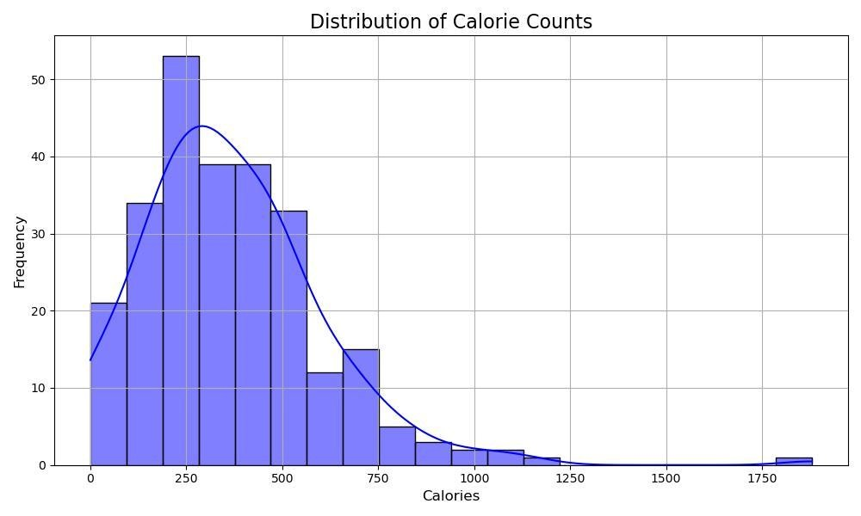

**The histogram shows the distribution of calorie counts in McDonald's menu items. Most items have between 200 and 500 calories, peaking around 250. As calories increase, the frequency drops significantly. The graph is right-skewed, with a few high-calorie outliers.**

|  |  |  |
| --- | --- | --- |
| **Category** | **Count of Menu Item** | **Centerpoint Calories** |
| **Beef & Pork** | **15** | **500** |
| **Beverages** | **27** | **100** |
| **Breakfast** | **42** | **470** |
| **Chicken & Fish** | **27** | **480** |
| **Coffee & Tea** | **95** | **270** |
| **Dessert** | **7** | **250** |
| **Salads** | **6** | **255** |
| **Smoothies & Shakes** | **28** | **540** |
| **Snacks & Sides** | **13** | **260** |

**The table provides an overview of various food categories from McDonald's menu, listing the number of items in each category and their centerpoint (median) calorie values. The Coffee & Tea category has the most items with 95, and a median calorie count of 270. Breakfast and Chicken & Fish categories have moderate counts, with 42 and 27 items respectively, and centerpoint calories around 470-480. On the higher end, Smoothies & Shakes have the highest median calories at 540, while Beverages and Desserts offer lower calorie options with centerpoints of 100 and 250 calories. Salads and Snacks & Sides offer lighter meals, with median calories around 255 and 260.**

**Exploring the nutritional content (e.g. fat, protein, carbohydrates) of different items by Category.**

|  |  |  |  |  |
| --- | --- | --- | --- | --- |
| **Category** | **Count of Menu Item** | **Centerpoint Total Fat** | **Centerpoint Protein** | **Centerpoint Carbohydrates** |
| **Beef & Pork** | **15** | **26** | **24** | **41** |
| **Beverages** | **27** | **0** | **0** | **27** |
| **Breakfast** | **42** | **26** | **19** | **45** |
| **Chicken & Fish** | **27** | **21** | **27** | **44** |
| **Coffee & Tea** | **95** | **7** | **10** | **45** |
| **Dessert** | **7** | **8** | **2** | **32** |
| **Salads** | **6** | **8** | **24** | **21** |
| **Smoothies & Shakes** | **28** | **16** | **12** | **88** |
| **Snacks & Sides** | **13** | **11** | **6** | **30** |

**The table summarizes McDonald's menu categories, showing median values for total fat, protein, and carbohydrates. Beef & Pork items have the highest fat (26g) and significant protein (24g). Breakfast and Chicken & Fish items also contain moderate fat and protein. Smoothies & Shakes have the highest carbohydrates (88g), while Beverages and Desserts are lighter, with minimal protein and fat. Salads and Snacks & Sides offer moderate carbohydrates with lower fat and protein content.**

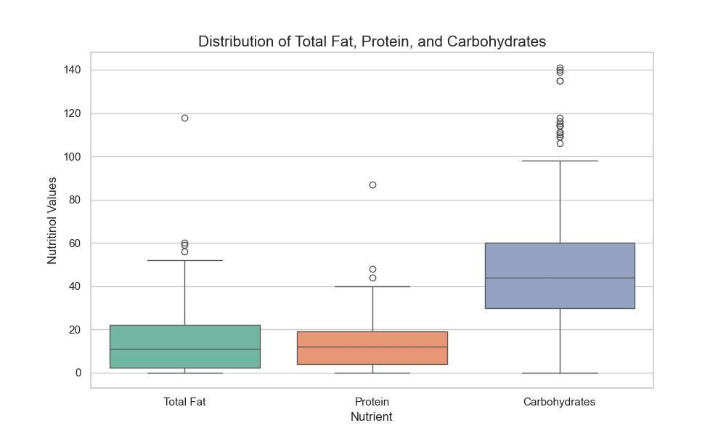

|  |  |  |  |
| --- | --- | --- | --- |
|  | **Total Fat** | **Protein** | **Carbohydrates** |
| **count** | **260** | **260** | **260** |
| **mean** | **14.16** | **13.33** | **47.34** |
| **std** | **14.21** | **11.43** | **28.25** |
| **min** | **0** | **0** | **0** |
| **25%** | **2.38** | **4.00** | **30.00** |
| **50%** | **11.00** | **12.00** | **44.00** |
| **75%** | **22.25** | **19.00** | **60.00** |
| **max** | **118.00** | **87.00** | **141.00** |

**The table summarizes the nutritional content of McDonald's menu items, focusing on total fat, protein, and carbohydrates. On average, items contain 14.16g of fat, 13.33g of protein, and 47.34g of carbohydrates. The range varies widely, with fat going from 0g to**

**118g, protein from 0g to 87g, and carbohydrates from 0g to 141g. Median values are 11g for fat, 12g for protein, and 44g for carbohydrates, providing insight into the typical nutritional content of the menu.**

**Insights into food categories by vital nutrients:**

**Exploring food categories with box plots and tables enables a deeper understanding of vital nutrient variations, supporting nutrition-focused analysis.**

1. **Calories Box plot**

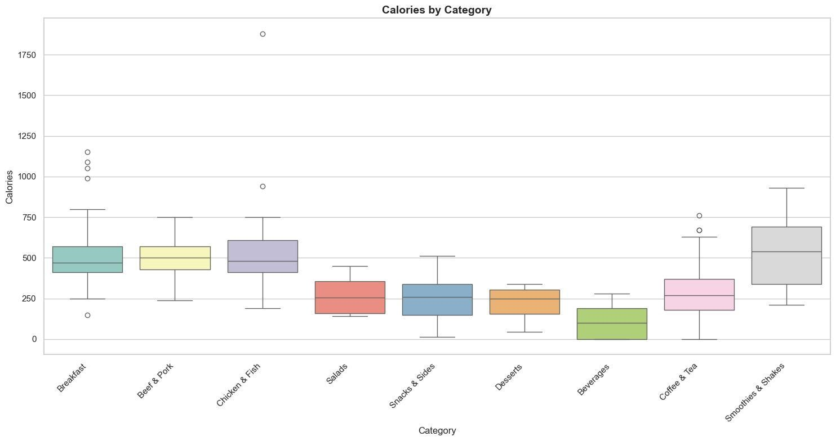

|  |  |  |  |  |  |  |  |  |
| --- | --- | --- | --- | --- | --- | --- | --- | --- |
| **Category** | **count** | **mean** | **std** | **min** | **25%** | **50%** | **75%** | **max** |
| **Beef & Pork** | **15** | **494.0** | **141.4** | **240.0** | **430.0** | **500.0** | **570.0** | **750.0** |
| **Beverage** | **27** | **113.7** | **99.2** | **0** | **0** | **100.0** | **190.0** | **280.0** |
| **BreakFast** | **42** | **526.7** | **221.8** | **150.0** | **410.0** | **470.0** | **570.0** | **1150.0** |
| **Chicken & Fish** | **27** | **553.0** | **306.5** | **190.0** | **410.0** | **480.0** | **610.0** | **1880.0** |
| **Coffee & Tea** | **95** | **283.9** | **157.8** | **0** | **180.0** | **270.0** | **370.0** | **760.0** |
| **Dessert** | **7** | **222.1** | **108.1** | **45.0** | **155.0** | **250.0** | **305.0** | **340.0** |
| **Salads** | **6** | **270.0** | **127.4** | **140.0** | **160.0** | **255.0** | **357.5** | **450.0** |
| **Smoothies & Shakes** | **28** | **531.4** | **230.9** | **210.0** | **337.5** | **540.0** | **692.5** | **930.0** |
| **Snacks & Slides** | **13** | **245.8** | **141.8** | **15.0** | **150.0** | **260.0** | **340.0** | **510.0** |

1. **Carbohydrates Box plot**

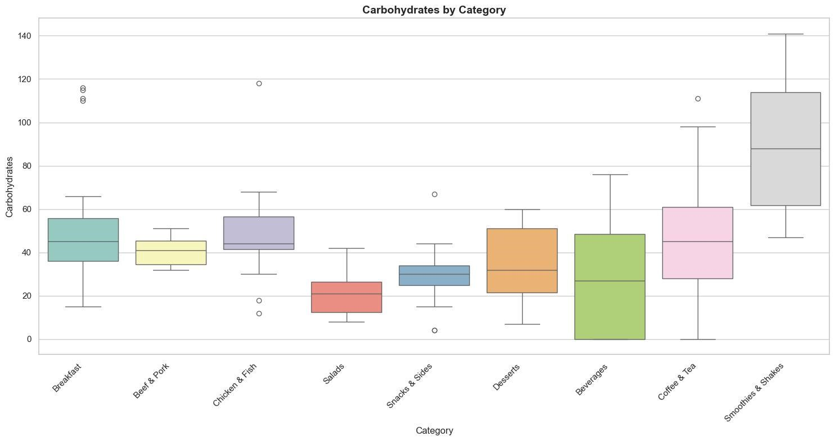

|  |  |  |  |  |  |  |  |  |
| --- | --- | --- | --- | --- | --- | --- | --- | --- |
| **Category** | **count** | **mean** | **std** | **min** | **25%** | **50%** | **75%** | **max** |
| **Beef & Pork** | **15** | **40.1** | **6.4** | **32.0** | **34.5** | **41.0** | **45.5** | **51.0** |
| **Beverage** | **27** | **28.8** | **26.1** | **0** | **0** | **27.0** | **48.5** | **76.0** |
| **BreakFast** | **42** | **49.8** | **23.4** | **15.0** | **36.0** | **45.0** | **55.8** | **116.0** |
| **Chicken & Fish** | **27** | **49.1** | **18.9** | **12.0** | **41.5** | **44.0** | **56.5** | **118.0** |
| **Coffee & Tea** | **95** | **44.5** | **23.6** | **0** | **28.0** | **45.0** | **61.0** | **111.0** |
| **Dessert** | **7** | **34.9** | **19.6** | **7.0** | **21.5** | **32.0** | **51.0** | **60.0** |
| **Salads** | **6** | **21.7** | **12.5** | **8.0** | **12.5** | **21.0** | **26.5** | **42.0** |
| **Smoothies & Shakes** | **28** | **90.4** | **30.9** | **47.0** | **61.8** | **88.0** | **114.0** | **141.0** |
| **Snacks & Slides** | **13** | **29.2** | **16.4** | **4.0** | **25.0** | **30.0** | **34.0** | **67.0** |

**3.Dietary Fiber Box plot**

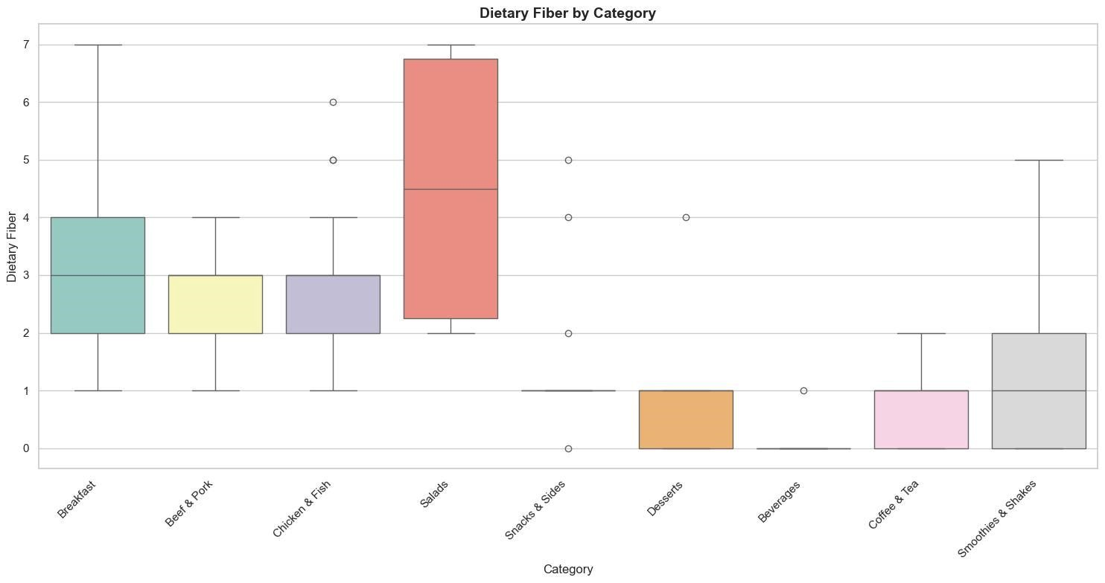

|  |  |  |  |  |  |  |  |  |
| --- | --- | --- | --- | --- | --- | --- | --- | --- |
| **Category** | **count** | **mean** | **std** | **min** | **25%** | **50%** | **75%** | **max** |
| **Beef & Pork** | **15** | **2.53** | **0.74** | **1.0** | **3.00** | **3.00** | **3.00** | **4.00** |
| **Beverage** | **27** | **0.03** | **0.19** | **0** | **0** | **0** | **0** | **1.00** |
| **BreakFast** | **42** | **3.26** | **1.39** | **1.0** | **2.00** | **3.00** | **4.00** | **7.00** |
| **Chicken & Fish** | **27** | **2.92** | **1.14** | **1.0** | **2.00** | **3.00** | **3.00** | **6.00** |
| **Coffee & Tea** | **95** | **0.77** | **0.62** | **0** | **0** | **1.00** | **1.00** | **2.00** |
| **Dessert** | **7** | **1.00** | **1.41** | **0** | **0** | **1.00** | **1.00** | **4.00** |
| **Salads** | **6** | **4.50** | **2.42** | **2.0** | **2.25** | **4.50** | **6.75** | **7.00** |
| **Smoothies & Shakes** | **28** | **1.46** | **1.40** | **0** | **0** | **1.00** | **2.00** | **5.00** |
| **Snacks & Slides** | **13** | **1.53** | **1.39** | **0** | **1.0** | **1.00** | **1.00** | **5.00** |

**4.Protein Box Plot:**

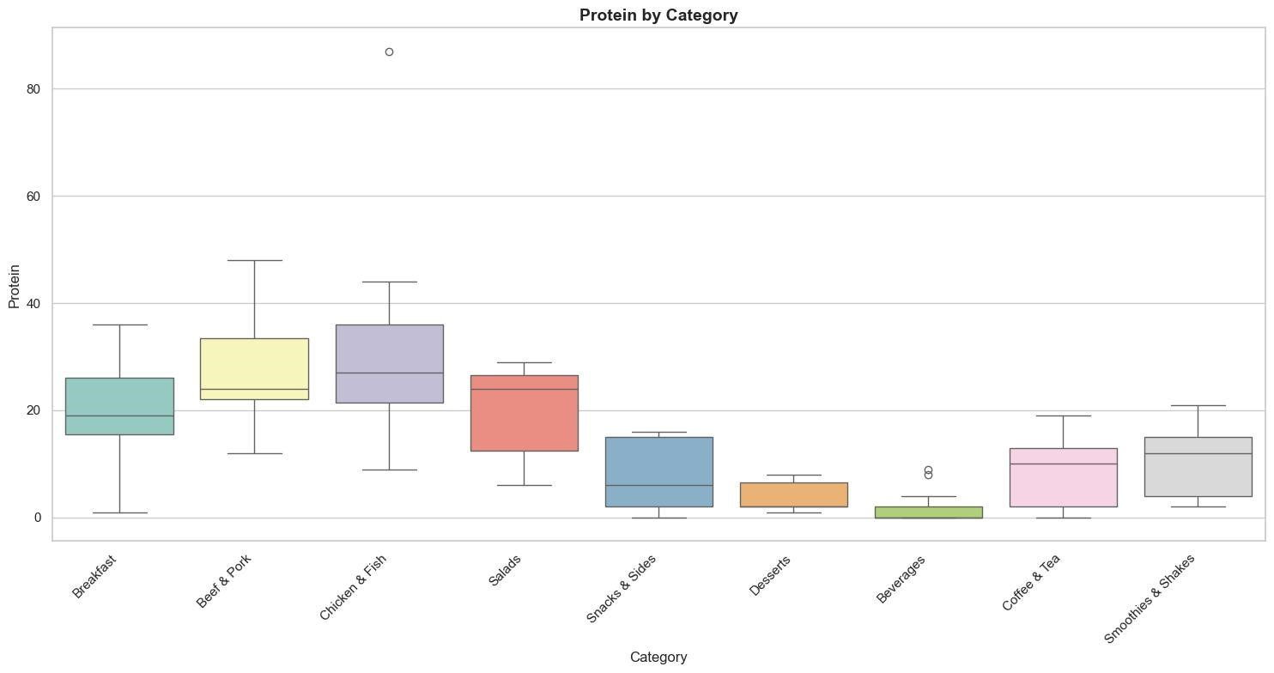

|  |  |  |  |  |  |  |  |  |
| --- | --- | --- | --- | --- | --- | --- | --- | --- |
| **Category** | **count** | **mean** | **std** | **min** | **25%** | **50%** | **75%** | **max** |
| **Beef & Pork** | **15** | **27.33** | **9.57** | **12.00** | **22.00** | **24.00** | **33.50** | **48.00** |
| **Beverage** | **27** | **1.33** | **2.44** | **0** | **0** | **0** | **2.00** | **9.00** |
| **BreakFast** | **42** | **19.85** | **8.78** | **1.00** | **15.50** | **19.00** | **26.00** | **36.00** |
| **Chicken & Fish** | **27** | **29.11** | **14.76** | **9.00** | **21.50** | **27.00** | **36.00** | **87.00** |
| **Coffee & Tea** | **95** | **8.86** | **5.51** | **0** | **2.0** | **10.00** | **13.00** | **19.00** |
| **Dessert** | **7** | **4.00** | **2.88** | **1.00** | **2.0** | **2.00** | **6.50** | **8.00** |
| **Salads** | **6** | **19.83** | **9.80** | **6.00** | **12.50** | **24.00** | **26.50** | **29.00** |
| **Smoothies & Shakes** | **28** | **10.85** | **6.13** | **2.0** | **4.0** | **12.00** | **15.00** | **21.00** |
| **Snacks & Slides** | **13** | **8.38** | **6.73** | **0** | **2.0** | **6.00** | **15.00** | **16.00** |

**5. Vitamin A (% Daily Value)**

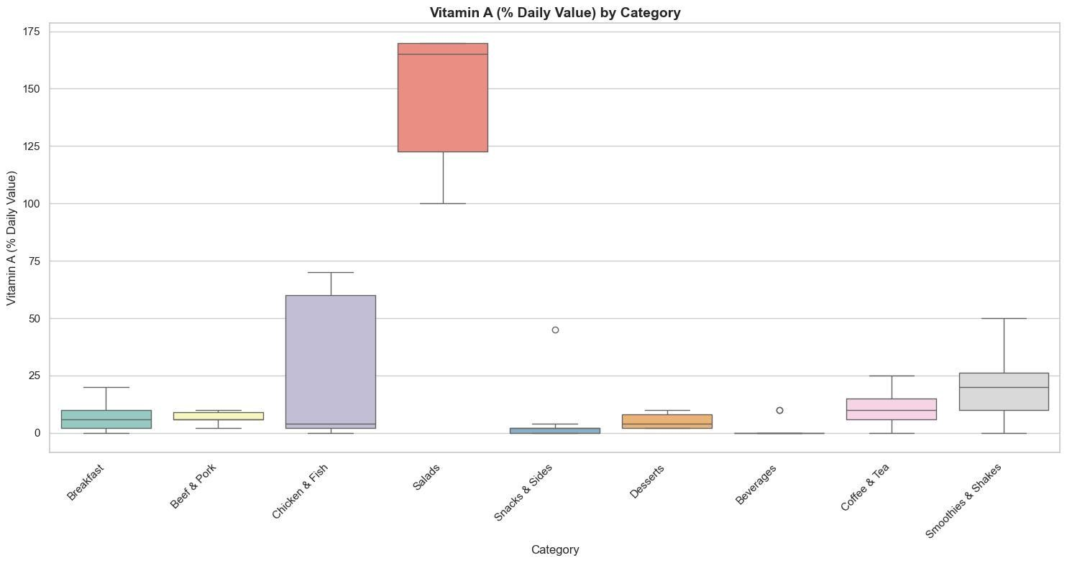

|  |  |  |  |  |  |  |  |  |
| --- | --- | --- | --- | --- | --- | --- | --- | --- |
| **Category** | **count** | **mean** | **std** | **min** | **25%** | **50%** | **75%** | **max** |
| **Beef & Pork** | **15** | **6.93** | **2.60** | **2.00** | **6.00** | **6.00** | **9.00** | **10.00** |
| **Beverage** | **27** | **0.74** | **2.66** | **0** | **0.00** | **0** | **0** | **10.00** |
| **BreakFast** | **42** | **6.92** | **6.01** | **0** | **2.00** | **6.00** | **10.00** | **20.00** |
| **Chicken & Fish** | **27** | **20.44** | **27.15** | **0** | **2.00** | **4.00** | **60.00** | **70.00** |
| **Coffee & Tea** | **95** | **10.73** | **6.10** | **0** | **6.00** | **10.00** | **15.00** | **25.00** |
| **Dessert** | **7** | **5.14** | **3.43** | **2.0** | **2.00** | **4.00** | **8.00** | **10.00** |
| **Salads** | **6** | **146.66** | **32.65** | **100.0** | **122.50** | **165.00** | **170.00** | **170.00** |
| **Smoothies & Shakes** | **28** | **18.75** | **13.09** | **0** | **10.0** | **20.00** | **26.25** | **50.00** |
| **Snacks & Slides** | **13** | **4.84** | **12.15** | **0** | **0** | **2.00** | **2.00** | **45.00** |

**6.Vitamin C (% Daily Value)**

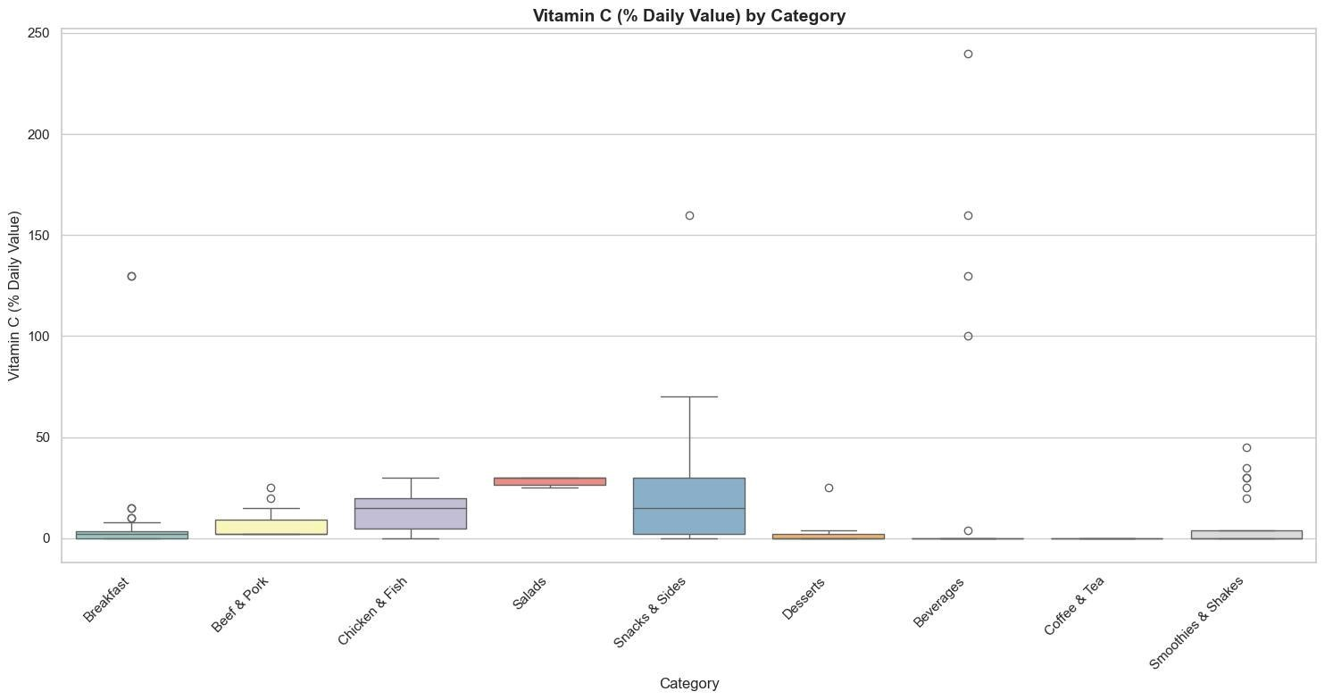

|  |  |  |  |  |  |  |  |  |
| --- | --- | --- | --- | --- | --- | --- | --- | --- |
| **Category** | **count** | **mean** | **std** | **min** | **25%** | **50%** | **75%** | **max** |
| **Beef & Pork** | **15** | **7.33** | **7.40** | **2.00** | **2.00** | **2.00** | **9.00** | **25.00** |
| **Beverage** | **27** | **23.48** | **60.51** | **0** | **0** | **0** | **0** | **240.00** |
| **BreakFast** | **42** | **8.90** | **27.69** | **0** | **0** | **2.00** | **3.50** | **130.00** |
| **Chicken & Fish** | **27** | **12.62** | **8.36** | **0** | **5.00** | **15.00** | **20.00** | **30.00** |
| **Coffee & Tea** | **95** | **0** | **0** | **0** | **0** | **0** | **0** | **0** |
| **Dessert** | **7** | **4.14** | **9.31** | **0** | **0** | **0** | **2.00** | **25.00** |
| **Salads** | **6** | **28.33** | **2.58** | **25.00** | **26.25** | **30.00** | **30.00** | **30.00** |
| **Smoothies & Shakes** | **28** | **6.96** | **13.26** | **0** | **0** | **0** | **4.00** | **45.00** |
| **Snacks & Slides** | **13** | **28.15** | **44.91** | **0** | **2.00** | **15.00** | **30.00** | **160.00** |

**7.Calcium (% Daily Value)**

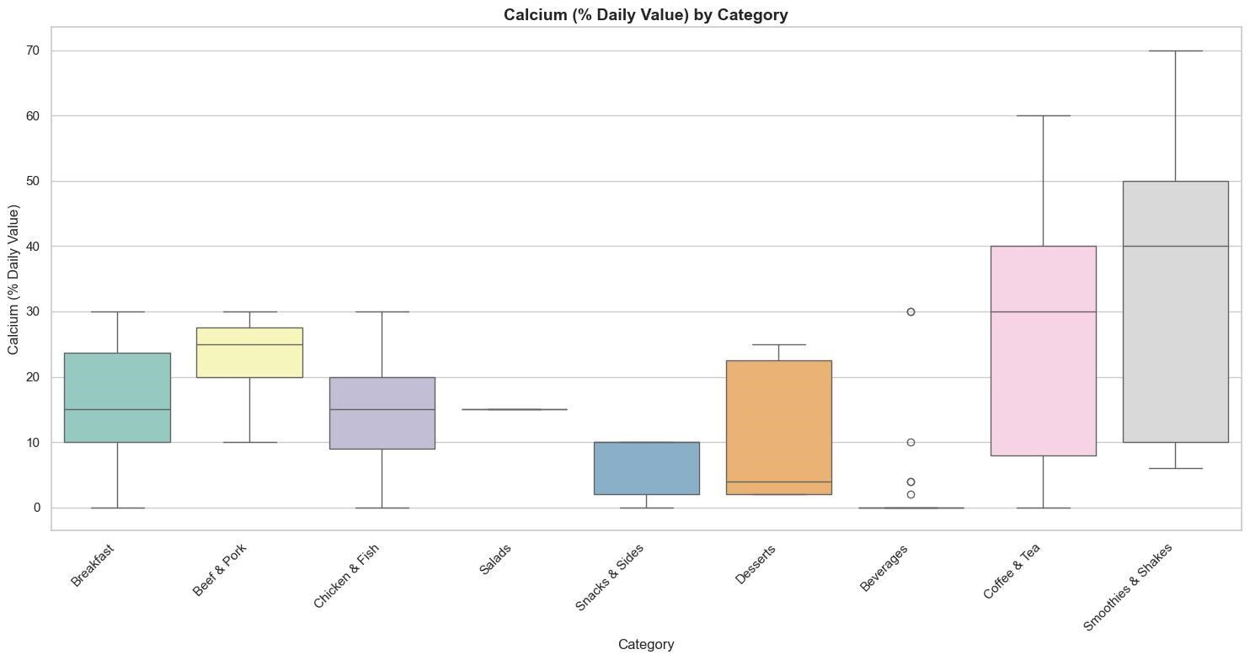

|  |  |  |  |  |  |  |  |  |
| --- | --- | --- | --- | --- | --- | --- | --- | --- |
| **Category** | **count** | **mean** | **std** | **min** | **25%** | **50%** | **75%** | **max** |
| **Beef & Pork** | **15** | **23.00** | **5.91** | **10.00** | **20.00** | **25.00** | **27.50** | **30.00** |
| **Beverage** | **27** | **2.96** | **8.08** | **0** | **0** | **0** | **0** | **30.00** |
| **BreakFast** | **42** | **16.16** | **7.82** | **0** | **10.00** | **15.00** | **23.75** | **30.00** |
| **Chicken & Fish** | **27** | **15.44** | **8.55** | **0** | **9.00** | **15.00** | **20.00** | **30.00** |
| **Coffee & Tea** | **95** | **28.29** | **17.62** | **0** | **8.00** | **30.00** | **40.00** | **60.00** |
| **Dessert** | **7** | **11.42** | **11.28** | **2.00** | **2.00** | **4.00** | **22.50** | **25.00** |
| **Salads** | **6** | **15.00** | **0** | **15.00** | **15.00** | **15.00** | **15.00** | **15.00** |
| **Smoothies & Shakes** | **28** | **35.57** | **21.75** | **6.00** | **10.00** | **40.00** | **50.00** | **70.00** |
| **Snacks & Slides** | **13** | **6.00** | **4.54** | **0** | **2.00** | **10.00** | **10.00** | **10.00** |

**8.Sodium:**

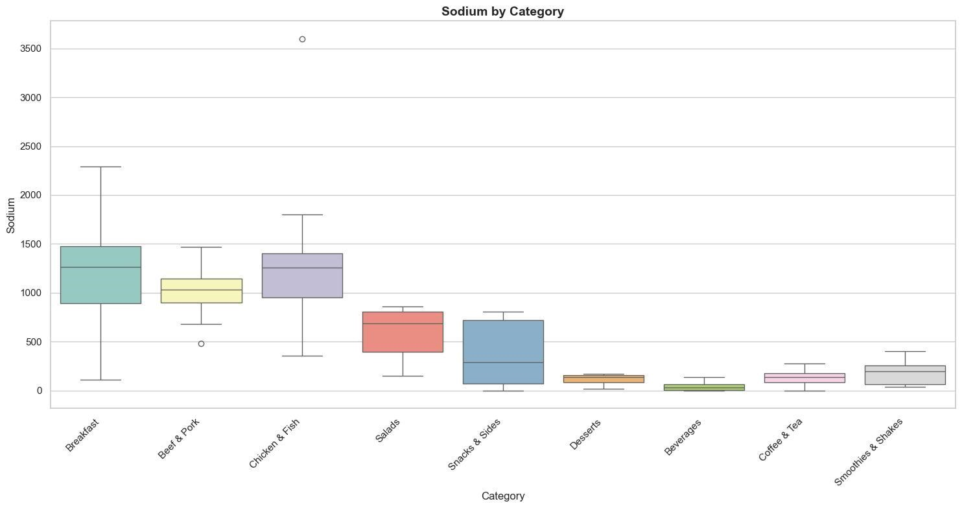

|  |  |  |  |  |  |  |  |  |
| --- | --- | --- | --- | --- | --- | --- | --- | --- |
| **Category** | **count** | **mean** | **std** | **min** | **25%** | **50%** | **75%** | **max** |
| **Beef & Pork** | **15** | **1020.6** | **267.7** | **480.0** | **900.0** | **1030.0** | **1145.0** | **1470.0** |
| **Beverage** | **27** | **41.5** | **43.4** | **0** | **5.0** | **30.0** | **62.5** | **140.0** |
| **BreakFast** | **42** | **1211.1** | **509.5** | **115.0** | **892.5** | **1265.0** | **1477.5** | **2290.0** |
| **Chicken & Fish** | **27** | **1257.8** | **584.4** | **360.0** | **950** | **1260.0** | **1405.0** | **3600.0** |
| **Coffee & Tea** | **95** | **136.9** | **74.1** | **0** | **85** | **140.0** | **180.0** | **280.0** |
| **Dessert** | **7** | **117.14** | **55.1** | **20.0** | **87.5** | **135.0** | **160.0** | **170.0** |
| **Salads** | **6** | **588.3** | **295.4** | **150.0** | **395.0** | **685.0** | **810.0** | **860.0** |
| **Smoothies & Shakes** | **28** | **183.6** | **110.9** | **40.0** | **63.8** | **195.0** | **260.0** | **400.0** |
| **Snacks & Slides** | **13** | **395.8** | **334.0** | **0** | **70.0** | **290.0** | **720.0** | **810.0** |

**9.Iron (% Daily Value):**

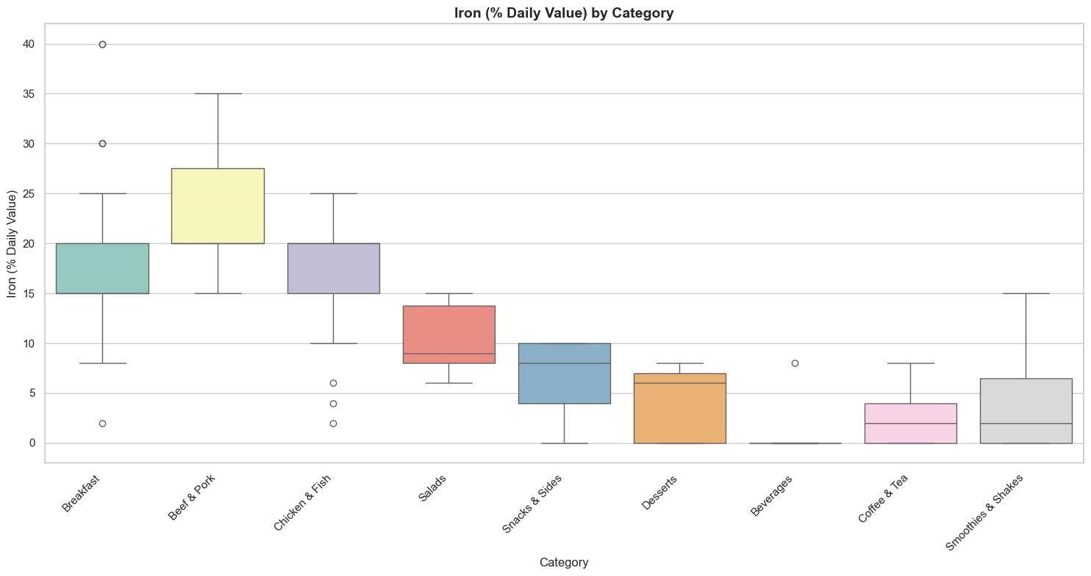

|  |  |  |  |  |  |  |  |  |
| --- | --- | --- | --- | --- | --- | --- | --- | --- |
| **Category** | **count** | **mean** | **std** | **min** | **25%** | **50%** | **75%** | **max** |
| **Beef & Pork** | **15** | **23.33** | **5.88** | **15.00** | **20.00** | **20.00** | **27.50** | **35.00** |
| **Beverage** | **27** | **0.30** | **1.54** | **0** | **0** | **0** | **0** | **8.00** |
| **BreakFast** | **42** | **17.14** | **7.92** | **2.00** | **15.00** | **15.00** | **20.00** | **40.00** |
| **Chicken & Fish** | **27** | **16.37** | **5.62** | **2.00** | **15.00** | **20.00** | **20.00** | **25.00** |
| **Coffee & Tea** | **95** | **2.14** | **2.54** | **0** | **0** | **2.00** | **4.00** | **8.00** |
| **Dessert** | **7** | **4.00** | **3.83** | **0** | **0** | **6.00** | **7.00** | **8.00** |
| **Salads** | **6** | **10.33** | **3.83** | **6.00** | **8.00** | **9.00** | **13.75** | **15.00** |
| **Smoothies & Shakes** | **28** | **3.96** | **4.04** | **0** | **0** | **2.00** | **6.50** | **15.00** |
| **Snacks & Slides** | **13** | **6.61** | **3.68** | **0** | **4.00** | **8.00** | **10.00** | **10.00** |

**10.Total Fat:**

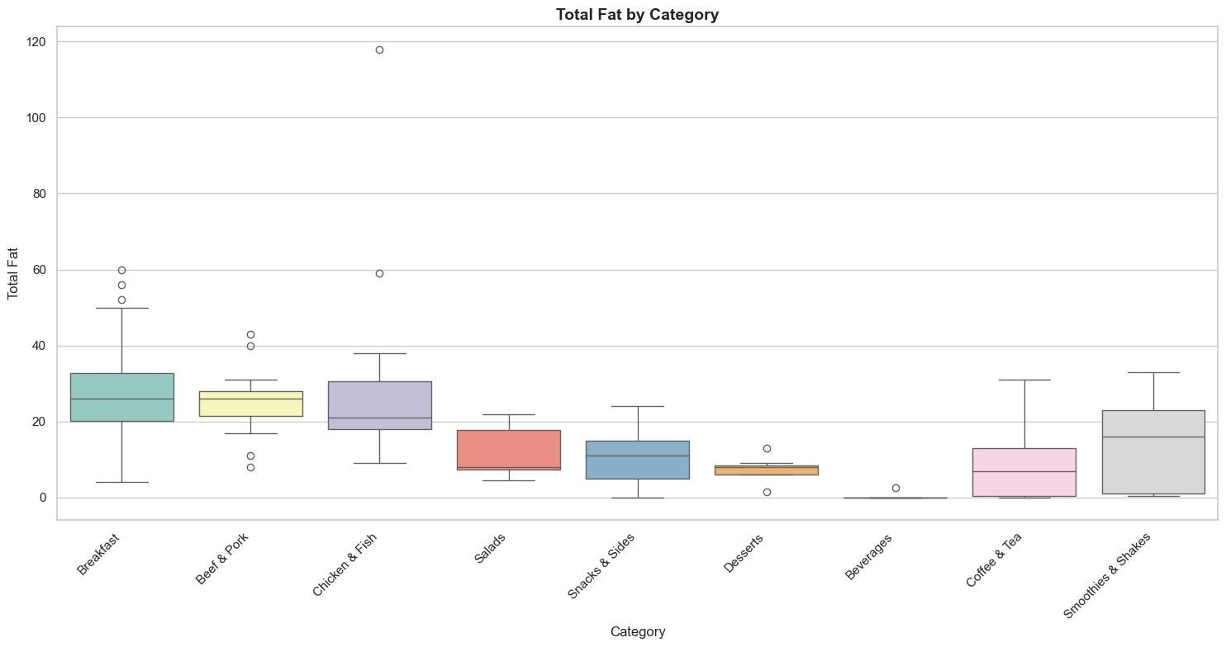

|  |  |  |  |  |  |  |  |  |
| --- | --- | --- | --- | --- | --- | --- | --- | --- |
| **Category** | **count** | **mean** | **std** | **min** | **25%** | **50%** | **75%** | **max** |
| **Beef & Pork** | **15** | **24.86** | **9.25** | **8.00** | **21.50** | **26.00** | **28.00** | **43.00** |
| **Beverage** | **27** | **0.09** | **0.48** | **0** | **0** | **0** | **0** | **2.50** |
| **BreakFast** | **42** | **27.69** | **13.34** | **4.00** | **20.25** | **26.00** | **32.75** | **60.00** |
| **Chicken & Fish** | **27** | **26.96** | **20.86** | **9.00** | **18.00** | **21.00** | **30.50** | **118.00** |
| **Coffee & Tea** | **95** | **8.02** | **7.44** | **0** | **0.50** | **7.00** | **13.00** | **31.00** |
| **Dessert** | **7** | **7.35** | **3.50** | **1.5** | **6.00** | **8.00** | **8.50** | **13.00** |
| **Salads** | **6** | **11.75** | **7.67** | **4.5** | **7.25** | **8.00** | **17.75** | **22.00** |
| **Smoothies & Shakes** | **28** | **14.13** | **10.37** | **0.5** | **1.00** | **16.00** | **23.00** | **33.00** |
| **Snacks & Slides** | **13** | **10.54** | **7.56** | **0** | **5.00** | **11.00** | **15.00** | **24.00** |

**12.Cholesterol:**

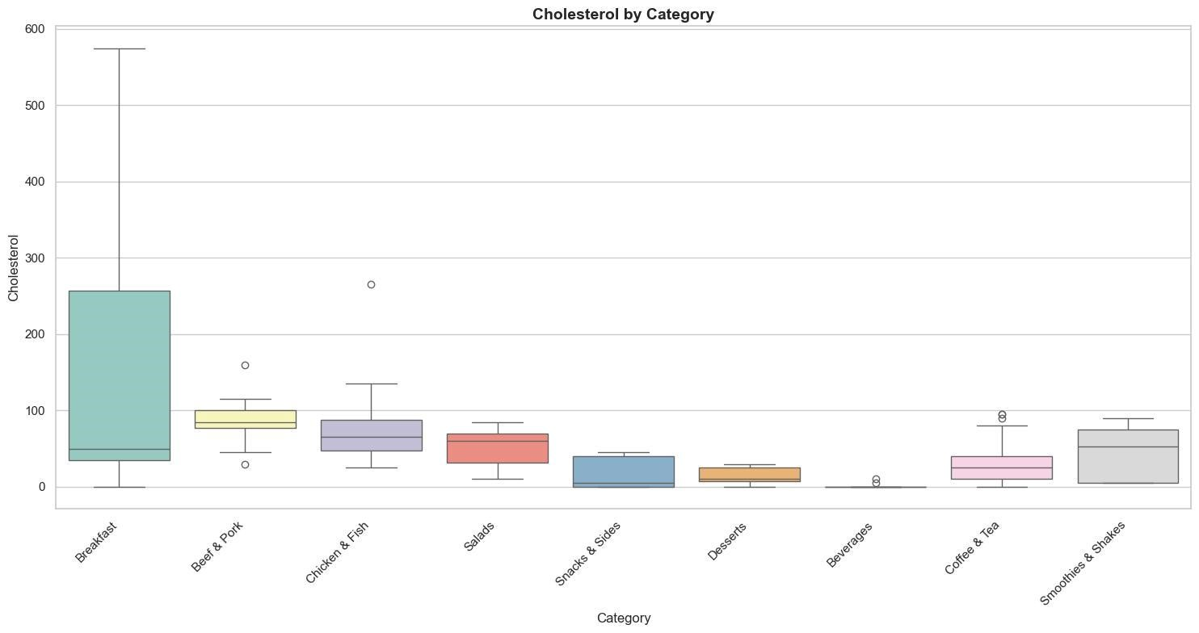

|  |  |  |  |  |  |  |  |  |
| --- | --- | --- | --- | --- | --- | --- | --- | --- |
| **Category** | **count** | **7mea0**  **0n** | **std** | **min** | **25%** | **50%** | **75%** | **max** |
| **Beef & Pork** | **15** | **87.33** | **29.75** | **30.00** | **77.50** | **85.00** | **100.00** | **160.00** |
| **Beverage** | **27** | **0.56** | **2.12** | **0** | **0** | **0** | **0** | **10.00** |
| **BreakFast** | **42** | **152.86** | **171.48** | **0** | **35.00** | **50.00** | **257.50** | **575.00** |
| **Chicken & Fish** | **27** | **75.37** | **45.91** | **25.00** | **47.50** | **65.00** | **87.50** | **265.00** |
| **Coffee & Tea** | **95** | **27.26** | **22.55** | **0** | **10.00** | **25.00** | **40.00** | **95.00** |
| **Dessert** | **7** | **15.00** | **11.55** | **0** | **7.50** | **10.00** | **25.00** | **30.00** |
| **Salads** | **6** | **51.67** | **29.09** | **10.00** | **31.25** | **60.00** | **70.00** | **85.00** |
| **Smoothies & Shakes** | **28** | **45.00** | **32.29** | **5.00** | **5.00** | **52.50** | **75.00** | **90.00** |
| **Snacks & Slides** | **13** | **18.46** | **20.35** | **0** | **0** | **5.00** | **40.00** | **45.00** |

**12.Sugars:**

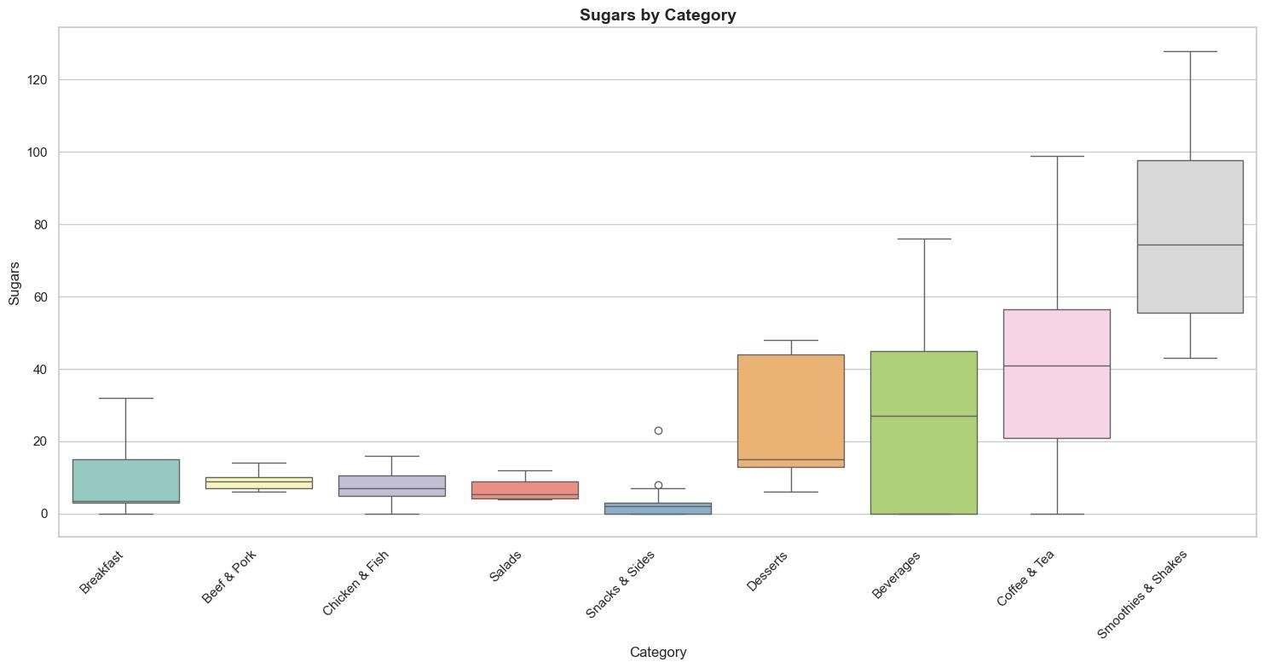

|  |  |  |  |  |  |  |  |  |
| --- | --- | --- | --- | --- | --- | --- | --- | --- |
| **Category** | **count** | **mean** | **std** | **min** | **25%** | **50%** | **75%** | **max** |
| **Beef & Pork** | **15** | **8.80** | **2.37** | **6.00** | **7.00** | **9.00** | **10.00** | **14.00** |
| **Beverage** | **27** | **27.85** | **25.44** | **0** | **0** | **27.00** | **45.00** | **76.00** |
| **BreakFast** | **42** | **8.26** | **7.99** | **0** | **3.00** | **3.50** | **15.00** | **32.00** |
| **Chicken & Fish** | **27** | **7.33** | **4.43** | **0** | **5.00** | **7.00** | **10.50** | **16.00** |
| **Coffee & Tea** | **95** | **39.61** | **22.35** | **0** | **21.00** | **41.00** | **56.50** | **99.00** |
| **Dessert** | **7** | **26.14** | **18.22** | **6.00** | **13.00** | **15.00** | **44.00** | **48.00** |
| **Salads** | **6** | **6.83** | **3.37** | **4.00** | **4.25** | **5.50** | **9.00** | **12.00** |
| **Smoothies & Shakes** | **28** | **77.89** | **25.77** | **43.00** | **55.50** | **74.50** | **97.75** | **128.00** |
| **Snacks & Slides** | **13** | **4.07** | **6.22** | **0** | **0** | **2.00** | **3.00** | **23.00** |

**The Box Plot and Table helps you understand all Food Category nutritional Values helps choose menu items wisely.**

**Visualizations:**

**Nutrition Navigator: Identifying Healthy and Less healthy Food Categories options:**

**Healthy Nutrients**

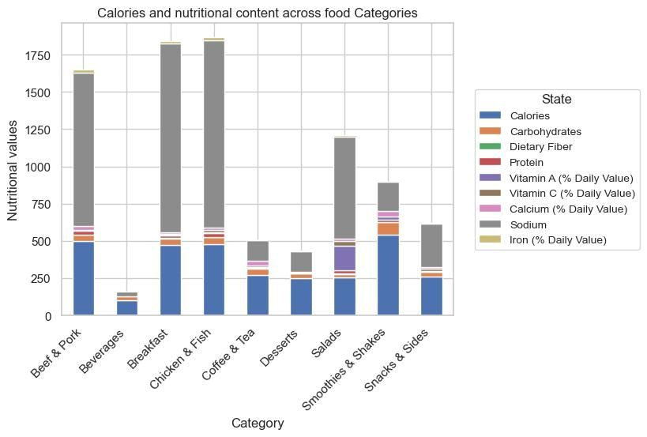

|  |  |  |  |  |  |  |  |  |  |
| --- | --- | --- | --- | --- | --- | --- | --- | --- | --- |
| **Category** | **calories** | **carbohydrates** | **Fiber** | **protein** | **Vit A** | **Vit C** | **calcium** | **sodium** | **iron** |
| **Beef & Pork** | **500** | **41** | **3.0** | **24.0** | **6.0** | **2.0** | **25.0** | **1030** | **20.0** |
| **Beverage** | **100** | **27** | **0** | **0** | **0** | **0** | **0** | **30** | **0** |
| **BreakFast** | **470** | **45** | **3.0** | **19.0** | **6.0** | **2.0** | **15.0** | **1265** | **15.0** |
| **Chicken & Fish** | **480** | **44** | **3.0** | **27.0** | **4.0** | **15.0** | **15.0** | **1260** | **20.0** |
| **Coffee & Tea** | **270** | **45** | **1.0** | **10.0** | **10.0** | **0** | **30.0** | **140** | **2.0** |
| **Dessert** | **250** | **32** | **1.0** | **2.0** | **4.0** | **0** | **4.0** | **135** | **6.0** |
| **Salads** | **255** | **21** | **4.5** | **24.0** | **165.0** | **30.0** | **15.0** | **685** | **9.0** |
| **Smoothies & Shakes** | **540** | **88** | **1.0** | **12.0** | **20.0** | **0** | **40.0** | **195** | **2.0** |
| **Snacks & Slides** | **260** | **30** | **1.0** | **6.0** | **2.0** | **15.0** | **10.0** | **290** | **8.0** |

**Less healthy Nutrients**

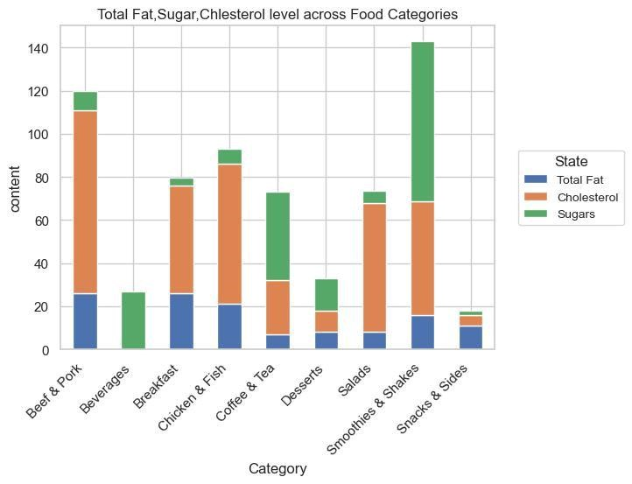

|  |  |  |  |
| --- | --- | --- | --- |
| **Category** | **Total Fat** | **Cholesterol** | **Sugars** |
| **Beef & Pork** | **26.0** | **85.0** | **9.0** |
| **Beverage** | **0** | **0** | **27.0** |
| **BreakFast** | **26.0** | **50.0** | **3.5** |
| **Chicken & Fish** | **21.0** | **65.0** | **7.0** |
| **Coffee & Tea** | **7.0** | **25.0** | **41.0** |
| **Dessert** | **8.0** | **10.0** | **15.0** |
| **Salads** | **8.0** | **60.0** | **5.5** |
| **Smoothies & Shakes** | **16.0** | **52.0** | **74.5** |
| **Snacks & Slides** | **11.0** | **5.0** | **2.0** |

**The stacked bar charts and accompanying tables offer a detailed comparison of both healthy and unhealthy nutrients across various food categories, helping consumers make informed dietary choices. For healthy nutrients, categories like Salads and Chicken & Fish stand out for their high protein, vitamins, and minerals such as Vitamin A, Vitamin C, and iron, while Smoothies & Shakes provide a boost of calcium. On the other hand, unhealthy nutrients like total fat, cholesterol, and sugars are notably higher in categories such as Beef & Pork, Smoothies & Shakes, and Beverages, signaling that these options should be consumed with caution due to their higher fat, cholesterol, and sugar content. This insight empowers individuals to balance their nutritional intake based on their health goals.**

**Determining the average nutritional content of popular menu categories.**

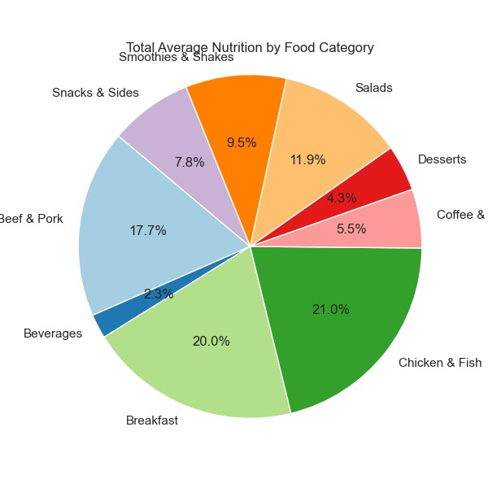

***The value shown in pie chart gives which food having good nutritional content***

**Nutritional Overview of Popular Menu Categories at McDonald's Breakfast:**

**The Breakfast category is a favorite among McDonald's customers, offering a balanced meal to start the day. It provides essential nutrients like protein, carbohydrates, and vitamins to fuel the morning. Many customers often pair breakfast with Coffee & Tea, which complements the meal, making it a perfect combination to kickstart the day.**

**Lunch:**

**The Chicken & Fish category is a popular lunch choice, packed with calories, carbohydrates, and essential vitamins. This menu option, rich in sodium and protein, can be enhanced when combined with items from the Salads and Smoothies & Shakes categories, offering a well-rounded and nutritious meal.**

**Dinner:**

**The Beef & Pork category is a top choice for dinner, featuring nutrient-dense items like burgers and wraps. Many customers pair these hearty meals with Beverages, Desserts, and Snacks & Sides. However, while delicious, this combination can be high in fat, cholesterol, and sugar, which may require moderation for those aiming for a balanced and healthy diet.**

**Benefits of Nutritional Analysis for McDonald's**

**Customers and Organization**

# For McDonald's Customers

**Conducting a detailed nutritional analysis can significantly benefit McDonald's customers in several ways:**

* **Informed Choices: Customers can make more informed decisions about their meals by understanding the calorie count and nutritional content of different items.**

**This helps them select meals that align with their dietary goals, whether they're looking for low-calorie, high-protein, or balanced meals.**

* **Healthier Eating Habits: By identifying which food categories offer the highest levels of beneficial nutrients like Protein, Dietary Fiber, and Vitamins, customers can plan their meals to include more nutritious items, promoting healthier eating habits.**
* **Customization: The analysis highlights specific menu items that may contain excessive fat, sodium, or sugar. This can guide customers who need to manage their intake of these nutrients due to medical conditions, such as hypertension or diabetes, enabling them to customize their meals to suit their health requirements.**
* **Dietary Preferences: Customers can easily find menu options that cater to specific dietary preferences or restrictions. For instance, identifying high-protein items like Chicken & Fish or low-calorie beverages can help those focused on weight management or muscle gain.**

# For McDonald's Organization

**McDonald's can leverage this nutritional analysis to drive both customer satisfaction and business growth:**

* **Menu Optimization: By understanding the nutritional distribution across their menu, McDonald's can optimize their offerings. They can adjust portion sizes, ingredient combinations, or create new items that meet customer demand for healthier options without compromising on taste.**
* **Targeted Marketing: Nutritional insights provide valuable data for targeted marketing campaigns. McDonald's can highlight healthy options such as Salads, Smoothies & Shakes, or low-calorie beverages to appeal to health-conscious customers, creating personalized promotions that resonate with different consumer segments.**
* **Improved Customer Loyalty: Offering transparent nutritional information fosters trust and strengthens the brand's relationship with its customers. By empowering customers to make informed decisions, McDonald's can build long-term loyalty, especially among health-conscious consumers.**
* **Compliance with Regulations: In many regions, regulations require businesses to provide detailed nutritional information to consumers. This analysis ensures McDonald's remains compliant with local laws and industry standards, avoiding legal penalties while maintaining transparency.**
* **New Product Development: Insights from the analysis can help McDonald's innovate new products that cater to the growing demand for healthier fast food. This can attract a broader audience, including those who previously avoided fast food due to health concerns.**

**Overall, the nutritional analysis not only enhances customer satisfaction by promoting healthier choices but also offers McDonald's the opportunity to innovate, optimize their menu, and maintain a competitive edge in the fast-food industry.**

# Recommendations on how McDonald's could improve the nutritional profile of their menu

**McDonald's can improve the nutritional profile of their menu by implementing the following recommendations:**

* **Reduce sodium, saturated fat, and added sugars in popular items to promote**

**healthier options.**

* **Incorporate leaner protein sources like grilled chicken or plant-based**

**alternatives to offer more balanced meals.**

* **Increase the availability of fresh vegetables and whole grains to enhance the**

**nutritional value of meals.**

* **Offer smaller portion sizes to help customers manage calorie intake more**

**easily.**

* **Provide greater transparency on ingredients to allow customers to make**

**informed, health-conscious choices.**

* **Adopt healthier cooking methods, such as baking instead of frying, to reduce**

**overall fat content in certain menu items.**

**These changes would not only support healthier eating habits but also align**

**McDonald's with evolving consumer preferences for nutritious and balanced meals.**

**Conclusion:**

**This analysis provides valuable insights into the nutritional content across various food categories at McDonald's, helping customers make more informed choices based on their dietary preferences. While categories like Chicken & Fish and Salads offer a balanced combination of proteins, vitamins, and minerals, others such as Beef & Pork and Smoothies & Shakes are higher in fat, cholesterol, and sugars, which may require careful moderation. By understanding the nutritional profiles of these menu items, consumers can tailor their meals to fit their nutritional goals, promoting healthier eating habits.**

**For Source code used for data preprocessing, analysis, and visualization visit Github repository:**